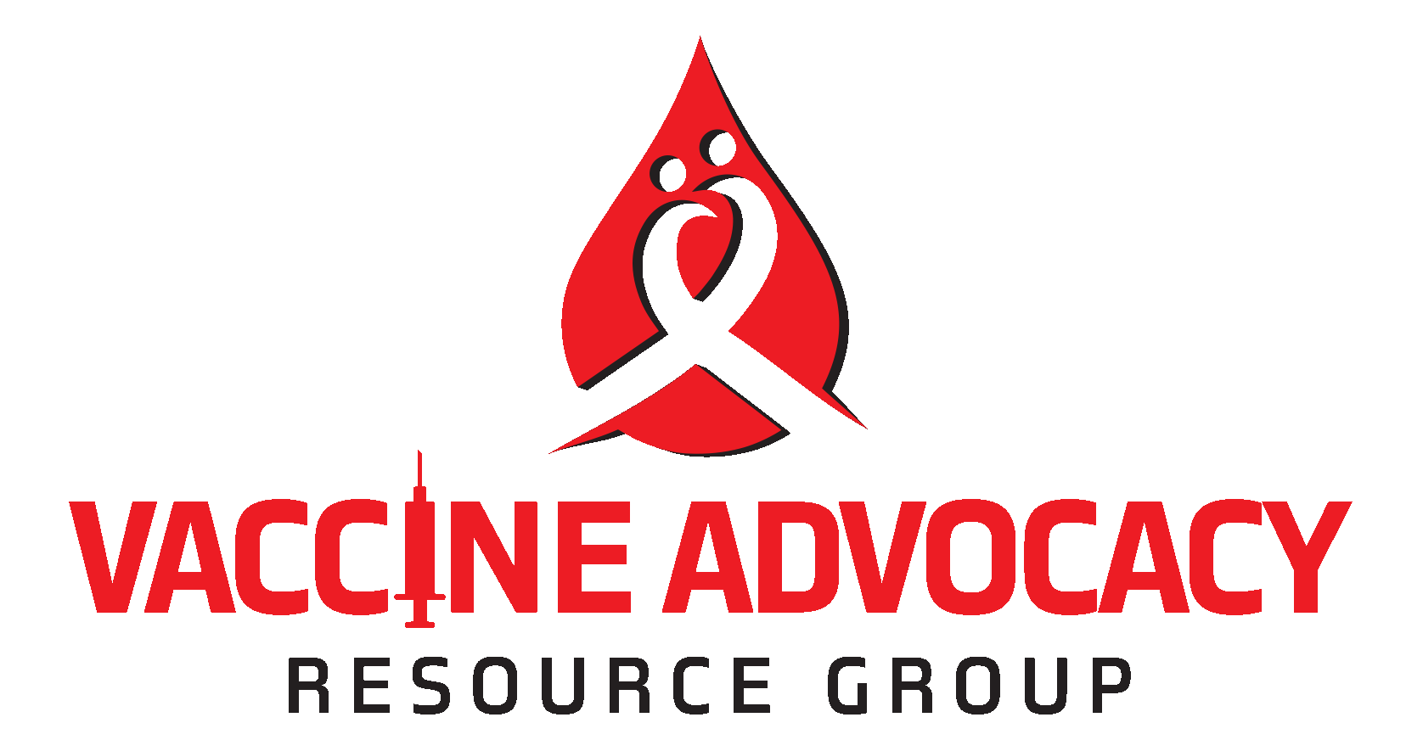
CONDUCT OF COVID-19 RELATED VACCINE RESEARCH THAT MEETS ETHICAL STANDARDS IN AFRICA
7TH April 2020
A recent exchange between a doctor and a researcher, in France, has raised issues about the ethical conduct of future vaccine trials against COVID-19 in Africa. This exchange reveals the structural racism of part of the western medical field but also the ignorance of the fundamental implication of African stakeholders (both researchers and civil society organizations) in dozens of trials. In view of this, and of the importance of an urgent global response to COVID-19 pandemic that requires clinical research to find biomedical products for prevention and treatment, The Vaccine Advocacy Research Group (VARG) wishes to reaffirm its support of the conduct of research that are scientifically valid and has ethical integrity. The VARG, a global group of vaccine advocates plays an oversight role for vaccine research, wherever it happens. We condemn any attempt to conduct COVID-19 related research in Africa for ethically unjustifiable reasons.
We consider the following as ethical standards acceptable for the conduct of COVID-19 related vaccine research in Africa:
- The research is designed by or in collaboration with local researchers working in the countries in Africa where the clinical trial or studies will take place. Where the research is initiated by international researchers, the local researcher should be involved in the design of the research protocol prior to submission of the protocol for review by ethics committee.
- Communities where research will be implemented are engaged in discussions about the research before the protocol is submitted for review by ethics committee. Communities can be engaged in the design of the research through active engagement with community representatives who are research literate. Adherence to social distancing is not be an excuse for not actively engaging with communities in the design of the research protocol.
- COVID-19 related research should be designated as research of national importance and should be reviewed by country designed ethics committees that have the mechanism to handle technical research protocols. These ethics committees should be able to access technical review experts to support the review of the science, and where necessary, are able to access technical support from the World Health Organization for technical review of protocols.
- Ethics Committees should prioritise the conduct of research that improves the standard of care for persons infected with COVID-19. The conduct of COVID-19 related research should not deplete human healthcare resources needed to help the governments diagnose and treat COVID-19.
- Ethics Committees should ensure there is a justification for the conduct of the research in the study population, that screening exercises ensures persons who test positive to SARS-CoV-2 gets their results if they so indicate, and they are supported to access care. Ethics Committees should sight the Memorandum of Understanding the research has with health institutions that are willing to take care of screened research participants who test positive to HIV.
- All COVID-19 related vaccine research should adopt the Ebola "Ring" Vaccine Trial design that promotes access of all eligible persons in a community to the vaccine through a deferred recruitment process. We associate with the trial design as it is ethically responsive to the culture of the region.
- Researchers should adhere to National Ethics guidelines. Also, adherence to the World Health Organization’s Good participatory practice guidelines for trials of emerging (and re-emerging) pathogens that are likely to cause severe outbreaks in the near future and for which few or no medical countermeasures exist (GPP-EP).
- Civil Society and community representatives who are contacted to support the conduct of COVID-19 related research should refer to the UNAIDS/WHO Good Participatory Guidelines to familiarize themselves with the minimum standards for engaging with researchers in the design and implementation of biomedical research.

Queries: Tian Johnson, +27734324069, tian@africanalliance.org.za, www.thevarg.org @vaccineadvocacy

This exchange has taken place on April 1. between Pr. Jean-Paul Mira (chief of Intensive Care at Cochin Hospital) and Camille Locht, researcher at the French National Health Institute (Inserm):“If I can be provocative, shouldn't we do this study in Africa, where there are no masks, no treatment, no resuscitation, a bit like it is done elsewhere on some studies with AIDS, or in prostitutes: we try things because we know they are highly exposed. What do you think? "asks Jean-Paul Mira. And Camille Locth answers: " You are right "

